After adding the code to the Apps and Drivers,

1. If you do not want a dashboard tiles skip to step 9.
2. Create a new virtual device using the KeenectLiteDisplay Driver
3. Set the IDE logging to whatever level you desire
4. Click Save Preferences and then Save Device
5. Repeat for all zones

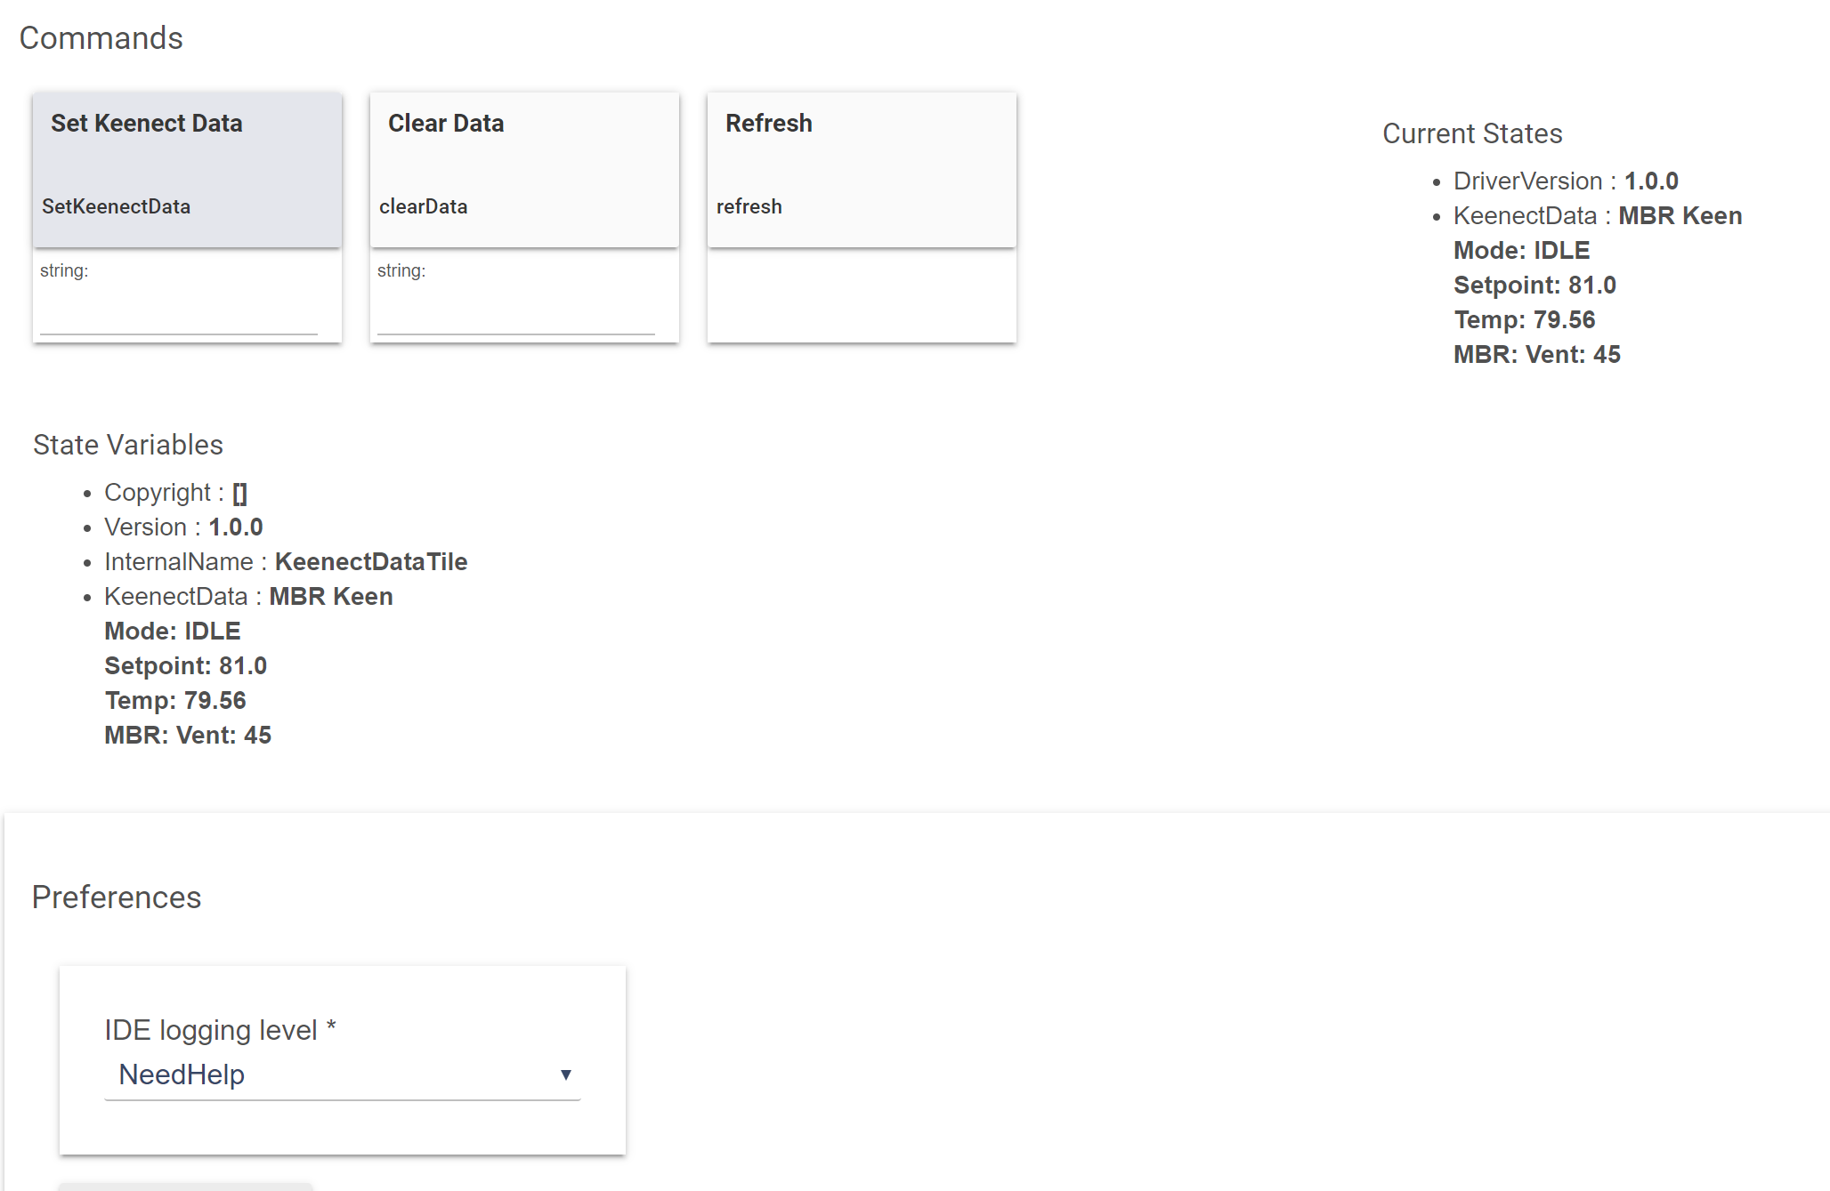

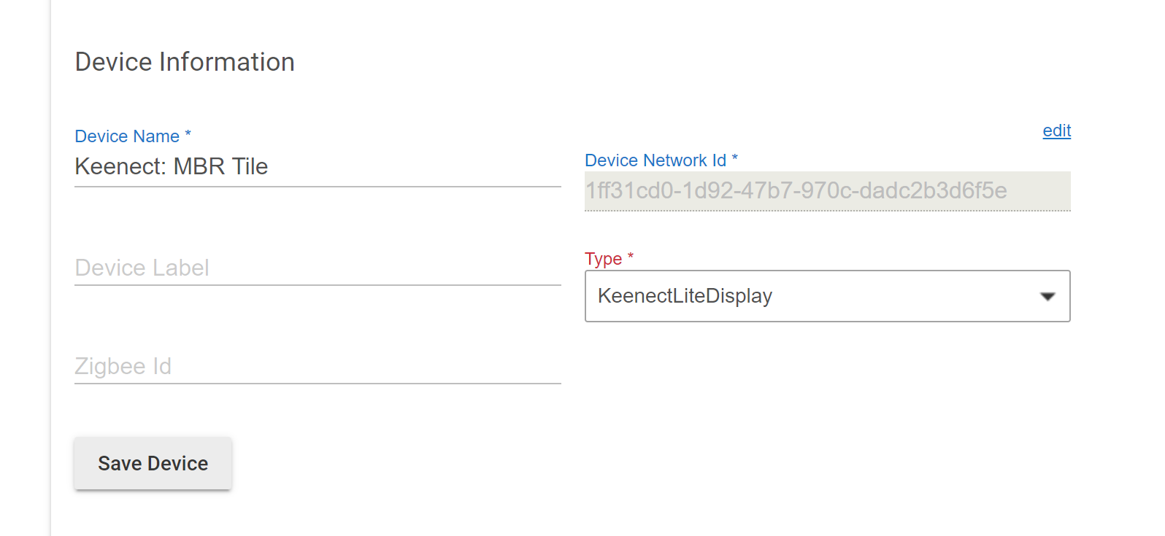

1. Go to the dashboard you want the tiles in and create a new tile
2. Select the device, for Template: Attribute, for Options-> Pick an Attribute, select KeenectData

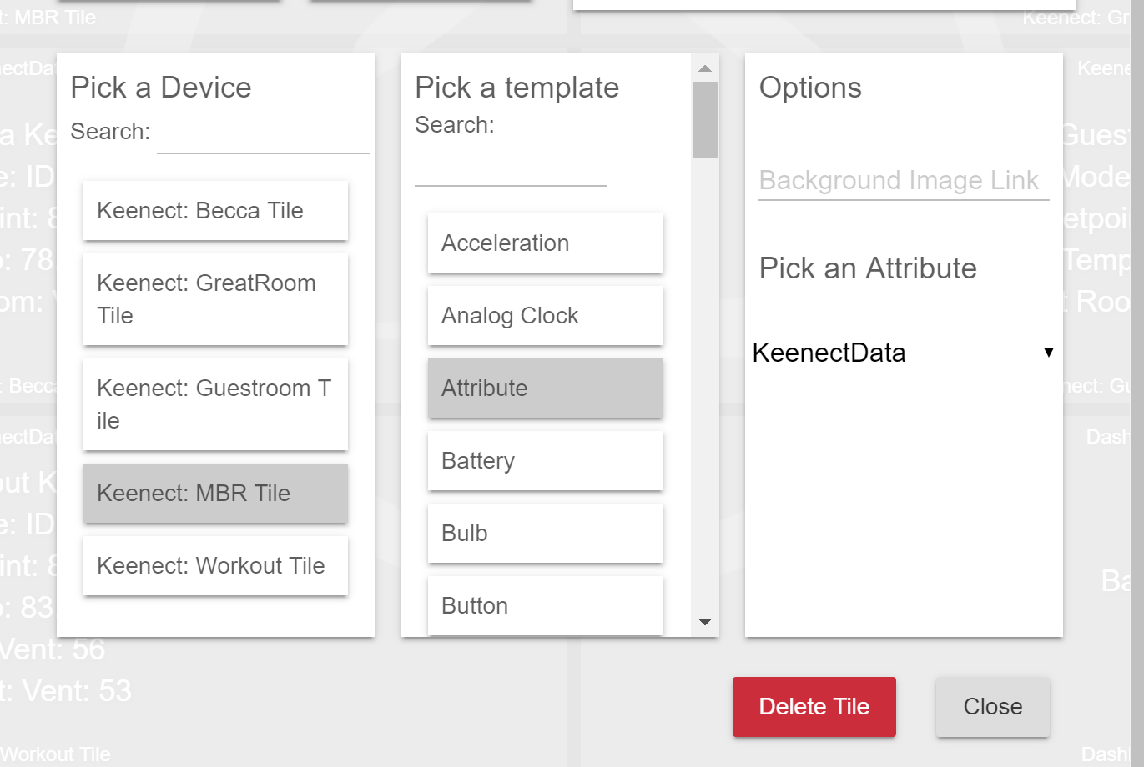

1. Repeat for all Zones
2. Add a user app and select KeenectLiteMaster
3. Select your main thermostat and if you are AC capable
4. Click Done
5. Before moving on, make sure you have a virtual thermostat for each zone you wish to have
6. Go open your instance of KeenectLiteMaster and now click Create New Vent Zone

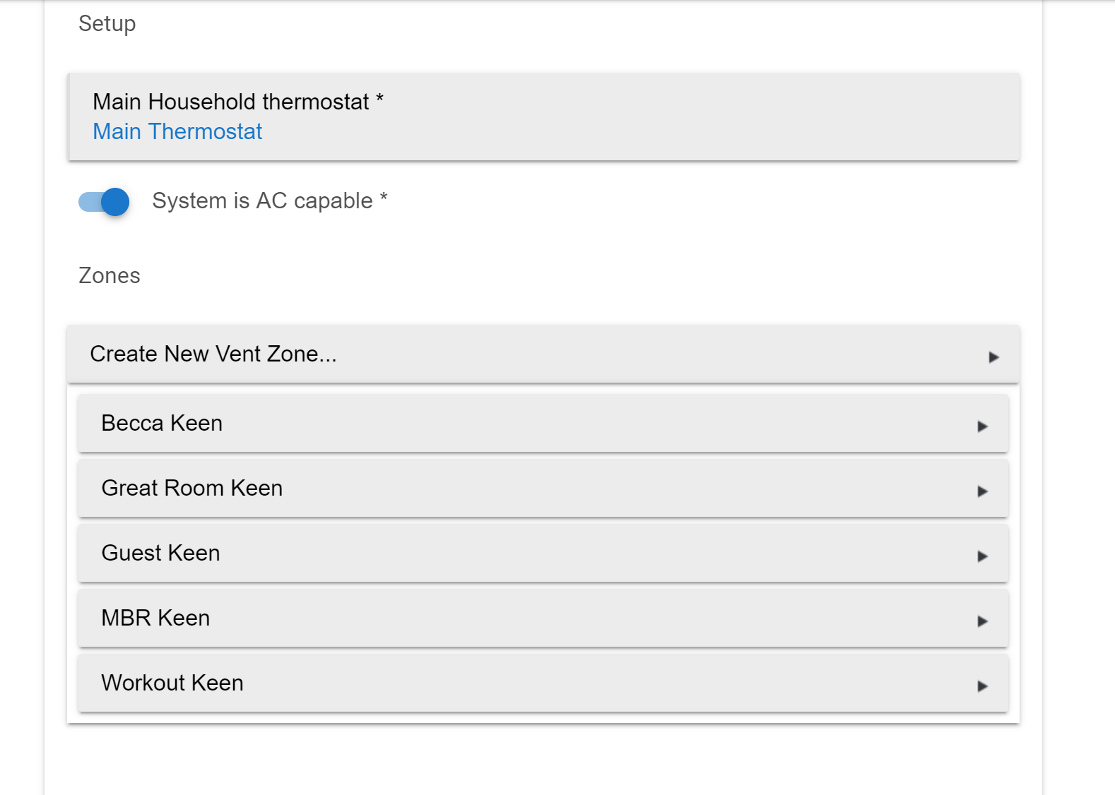

1. Add you virtual thermostat
2. Use Thermostat Mode to control vents causes the mode for your virtual thermostat to restrict controlling your vents.
   1. If the virtual thermostat is in heating, and you main thermostat starts cooling, the vent will be closed, and vice versa
3. Add you vent and temperature sensor.
4. If you created a display tile, add it too.

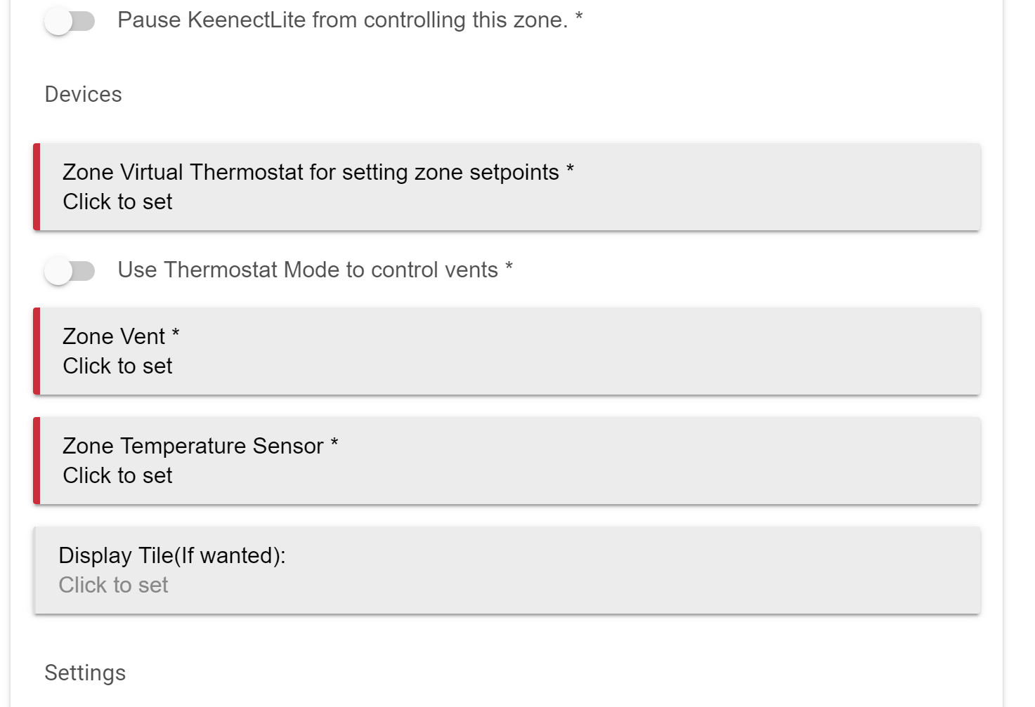

1. Reactive Fast means that the vent will stay open wider as you get closer to your temperature setpoint(.5 degrees) on your virtual thermostat, Slow means it will start closing further away (2 degrees) and Normal starts closing at 1 degree. Digital control is either fully open or fully closed, and never in between.
2. Vent opening min and max sets the limits of trave you want on your vents

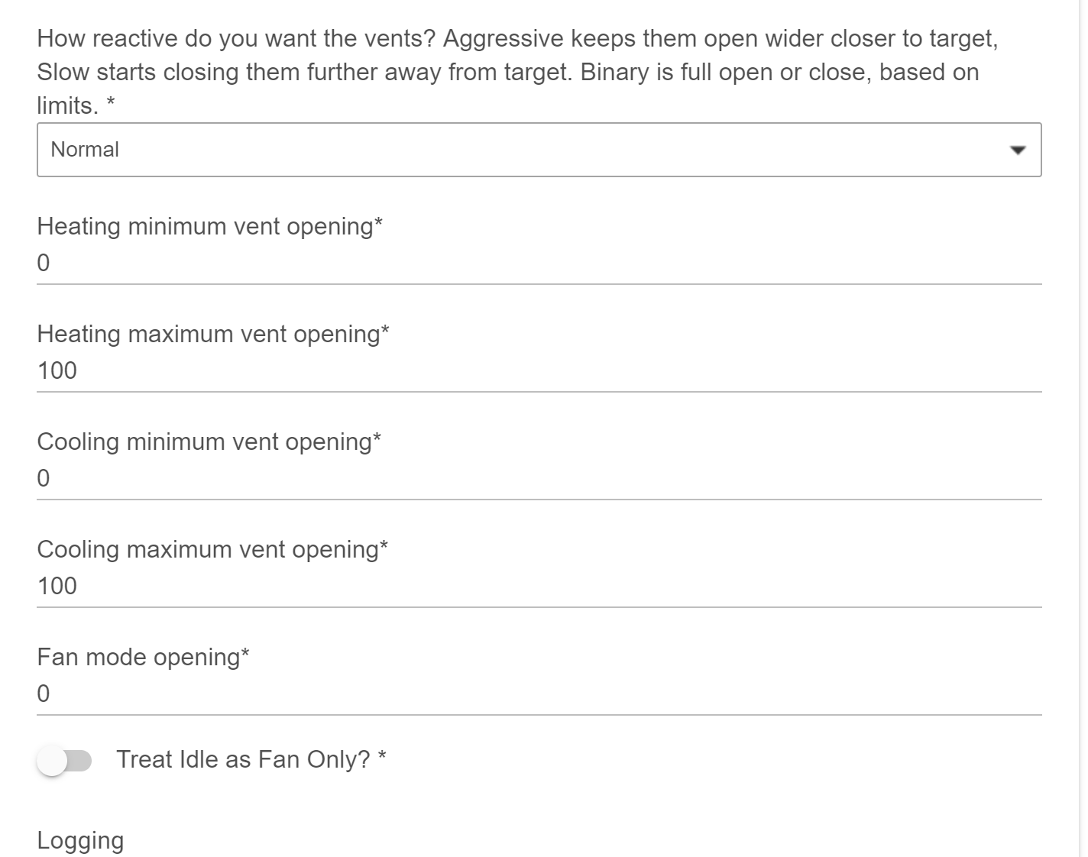

1. Logging level sets how verbose the logging is
2. Click Done.
3. Repeat for all zones

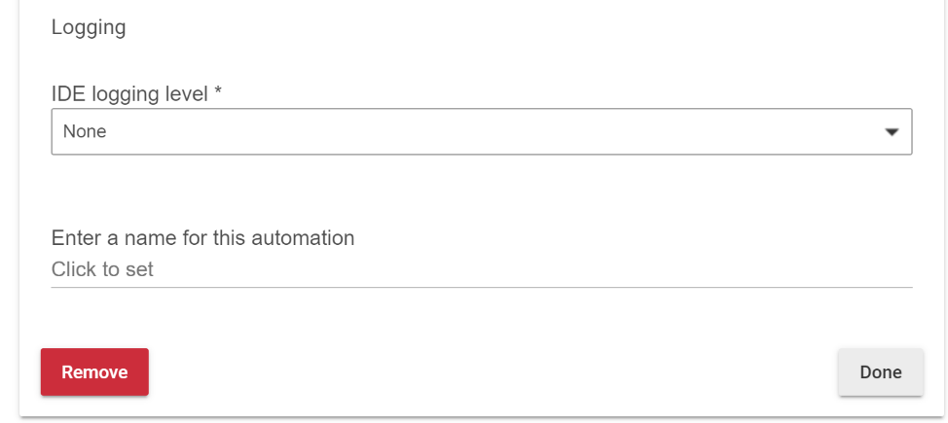

Your tiles get updated anytime the setpoint changes, the main thermostat starts running, a vent is moved , and when you hit done on the zone app.